Table of Contents
Blog Module Documentation 4
Introduction: 4
Features (User Side): 4
System Architecture: 5
Frontend Directory Architecture: 5
API Documentation: 6
Banner Module Integration: 13
Introduction: 13
System Architecture: 14
Frontend Directory Architecture: 14
API Documentation: 15
New Arrival Section Integration 18
Introduction: 18
Frontend Directory Architecture: 19
API Documentation: 19
New Launches Section Integration 23
Introduction: 23
Frontend Directory Architecture: 23
API Documentation: 24
Country-State-City-Suggestion Integration: 27
Introduction: 27
System Architecture: 28
Frontend Directory Architecture 30
Category Navigation Integration 32
Introduction: 32
System Workflow: 34
API Documentation: 34
FAQ Page Documentation 39
Introduction: 39
Implementation: 39
Frontend Directory Architecture: 39
Service Section (Homepage) 40
Introduction 40
System WorkFlow: 40
API Documentation 41

Blog Module Documentation

Introduction:
The Blog module allows users to read blog articles, interact with blog content, and engage through comments. Users can add comments on blogs, reply to existing comments, and delete their own comments. The module also displays related blogs to improve content discovery.
The frontend integration includes API integration, data handling, UI implementation, and manual testing with the admin panel to verify blog management functionality.

Features (User Side):
- Read Blog Details
The Blog Details feature allows users to view complete information about a selected blog, including its title, content, images, and other related details. The blog data is retrieved through API integration and displayed on the frontend. Related blogs are shown below the blog details section to help users explore similar content.
- Comment System
The Comment System allows users to interact with blog content by adding comments, viewing existing comments, replying to other users' comments, and deleting comments when required. This feature improves user engagement by allowing discussions and feedback directly within the blog.
- Related Blogs
The Displays suggested blog posts below the blog details section to help users discover additional content.
The Related Blogs section does not use a separate API endpoint. The blog list is fetched using the existing Get All Blogs API, and the frontend randomly shuffles the available blog data to display suggested blogs.
Implementation Flow
The frontend fetches the complete blog list using the Get All Blogs API.
The received blog data is passed to the Related Blogs component.
The blog list is shuffled randomly on the frontend.
A set of randomly selected blogs is displayed as related blog suggestions.
API Used: GET /blogs
Notes
- No separate related blog API is used.
- No recommendation algorithm or category-based filtering is implemented.
- Suggestions are generated through frontend-side random shuffling of available blogs.
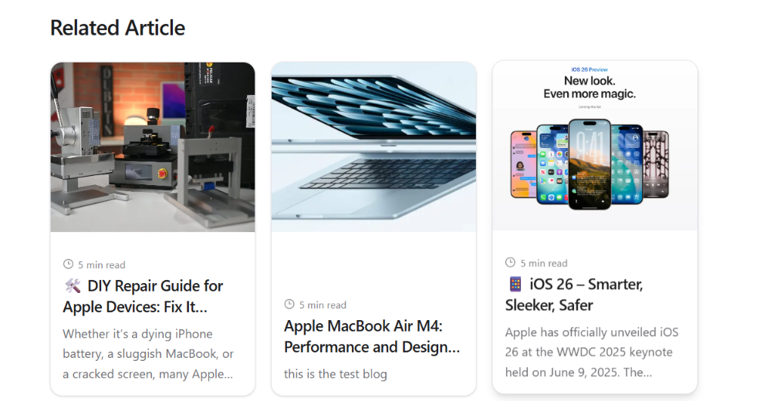
Fig: Related Article Section in Individual Blog bottom section

System Architecture:

Frontend Directory Architecture:
The Blog module follows a structured component-based architecture where page-level components, reusable UI components, utility functions, and API communication logic are separated into different directories. This organization improves maintainability and makes it easier for developers to locate and modify specific functionality.
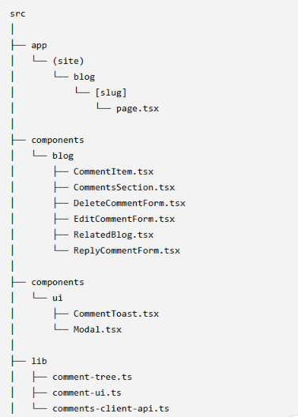
Fig: Frontend Architecture for Blog System Integration

API Documentation:
Base URL: https://demo.macstore.com.np/api
1. Get All Blogs
Returns a list of all published blog posts.
Endpoint
GET /blogs
Request
GET https://demo.macstore.com.np/api/blogs
Response (200 OK)
[
{
"id": 1,
"title": "Test Blog 1",
"slug": "test-blog-1",
"excerpt": "Short description...",
"created_at": "2026-06-15"
}
]
2. Get Single Blog
Returns the complete details of a specific blog using its slug.
Endpoint
GET /blogs/{slug}
Path Parameters
Parameter | Type | Description
slug | string | Unique slug of the blog
Example Request
GET https://demo.macstore.com.np/api/blogs/test-blog-1
Response (200 OK)
{
"id": 1,
"title": "Test Blog 1",
"slug": "test-blog-1",
"content": "<p>Blog content...</p>",
"created_at": "2026-06-15"
}
3. Get Blog Comments
Returns all comments associated with a specific blog.
Endpoint
GET /blogs/{blog_id}/comments
Path Parameters
Parameter | Type | Description
blog_id | integer | ID of the blog
Example Request
GET https://demo.macstore.com.np/api/blogs/2/comments
Response (200 OK)
[
{
"id": 1,
"name": "John Doe",
"comment": "Great article!",
"created_at": "2026-06-20"
},
{
"id": 2,
"name": "Jane Smith",
"comment": "Very informative.",
"created_at": "2026-06-21"
}
]
4. Create Blog Comment / Reply Comment:
Creates a new comment for a blog. The same API is used for both creating a new comment and replying to an existing comment.
When creating a normal comment, only blog_id is required. When replying to an existing comment, the parent_id field is included to associate the new comment with the parent comment.
Endpoint
POST /comments
Headers
Content-Type: application/json
Request Body
Field | Type | Required | Description
blog_id | integer | Yes | ID of the blog
parent_id | integer | No | ID of the parent comment. Used when creating a reply
name | string | Yes | Commenter's name
email | string | Yes | Commenter's email
phone_number | string | Yes | Contact number
comment | string | Yes | Comment text
Example Request (New Comment)
POST https://demo.macstore.com.np/api/comments
{
"blog_id": 2,
"name": "Anjan Khadka",
"email": "anjankhadka199@gmail.com",
"phone_number": "9876543210",
"comment": "This was a very helpful article."
}
Success Response (201 Created)
{
"message": "Comment created successfully."
}
Example Request (Reply to Existing Comment):
POST https://demo.macstore.com.np/api/comments
{
"blog_id": 2,
"parent_id": 5,
"name": "Anjan Khadka",
"email": "anjankhadka199@gmail.com",
"phone_number": "9876543210",
"comment": "Thank you for sharing your thoughts."
}
Success Response (201 Created):
{
"message": "Comment created successfully."
}
Note: There is only one comment creation API. parent_id controls whether it is a normal comment or a reply. The frontend handles replies through ReplyCommentForm.tsx. The backend manages the comment relationship.
5. Update Existing Comment
Updates an existing comment with new information.
Endpoint
PUT /comments/{comment_id}
Path Parameters
Parameter | Type | Description
comment_id | integer | ID of the comment to update
Headers
Content-Type: application/json
Example Request
PUT https://demo.macstore.com.np/api/comments/6
Request Body
Field | Type | Required | Description
name | string | Yes | Commenter's name
email | string | Yes | Commenter's email
phone_number | string | Yes | Contact number
comment | string | Yes | Updated comment text
{
"name": "Anjan Khadka",
"email": "anjankhadka9@gmail.com",
"phone_number": "9872533210",
"comment": "Updated comment"
}
Success Response (200 OK)
{
"message": "Comment updated successfully."
}
6. Delete Comment
Deletes an existing comment from a blog.
Endpoint
DELETE /comments/{comment_id}
Path Parameters
Parameter | Type | Description
comment_id | integer | ID of the comment to delete

Example Request:
DELETE https://demo.macstore.com.np/api/comments/7
Request Body
Field | Type | Required | Description
name | string | Yes | Commenter's name
email | string | Yes | Commenter's email
phone_number | string | Yes | Contact number
{
"name": "Anjan Khadka",
"email": "anjankhadka39@gmail.com",
"phone_number": "9872535410"
}
Success Response (200 OK)
{
"message": "Comment deleted successfully."
}

Banner Module Integration:

Introduction:
The Announcement Bar feature provides a dynamic notification area displayed at the top of the website to communicate important updates, offers, announcements, or messages to users.
The banner automatically displays available announcements and allows users to view different notices without navigating away from the current page. This improves visibility of important information and provides a consistent way to communicate updates across the application.
The integration focuses on creating a user-friendly announcement experience where multiple notices can be displayed in an organized manner while maintaining a smooth and accessible user interface.
Fig: Banner Section of mac store client view
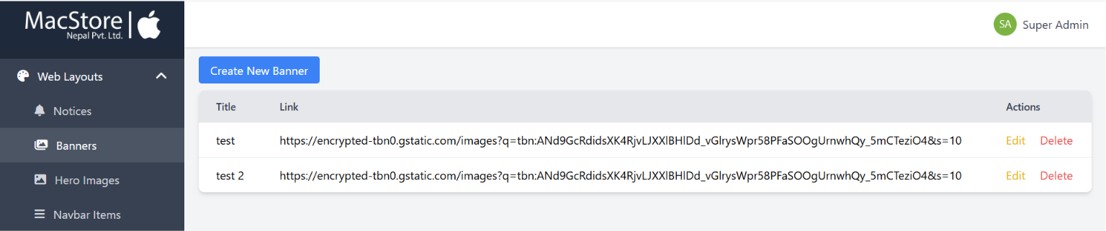
Fig: Admin Panel of mac store banner

System Architecture:
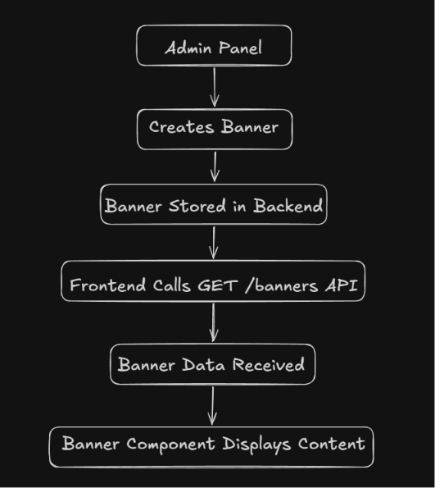
Fig: Flow Architecture of Banner

Frontend Directory Architecture:
The Banner module follows a structured component-based architecture where banner data fetching, type definitions, utility functions, and UI rendering are separated. The page component acts as the entry point, while reusable banner components handle the presentation and user interaction.
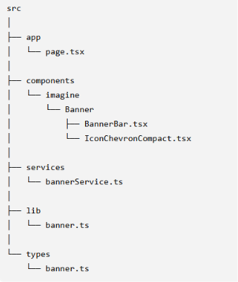
Fig: Directory Architecture of Banner Integration

API Documentation:
Base URL: https://demo.macstore.com.np/api
1. Get All Banners
Returns a list of all available banners created from the admin panel. The frontend uses this API to fetch banner information and display announcements/banners on the website.
Endpoint
GET /banners
Example Request
GET https://demo.macstore.com.np/api/banners
Response (200 OK)
[
{
"id": 6,
"title": "test",
"created_at": "2026-07-01T09:47:38.000000Z",
"updated_at": "2026-07-01T09:47:38.000000Z",
"link": "https://example.com/banner-image.jpg"
},
{
"id": 7,
"title": "test 2",
"created_at": "2026-07-06T06:33:50.000000Z",
"updated_at": "2026-07-06T06:33:50.000000Z",
"link": "https://example.com/banner-image.jpg"
}
]
Response Fields:
Field | Type | Description
id | integer | Unique identifier of the banner
title | string | Banner title or announcement text
link | string | Banner image URL or related banner link
created_at | datetime | Date and time when the banner was created
updated_at | datetime | Date and time when the banner was last updated

The API response is used by the frontend Banner module to display available banners.
The banner data is:
- Retrieved from the backend using the banner service.
- Passed to the banner component.
- Rendered on the website for users.
Notes:
- Banner creation and management are handled through the admin panel.
- The frontend only consumes the banner data through the API.
- Any new banner added from the admin panel becomes available through the banner listing API.

New Arrival Section Integration

Introduction:
The New Arrival section displays recently added products to help users discover the latest products available in the store. This section provides a dedicated area on the homepage where users can browse newly added items and quickly navigate to the respective product details page.
The section retrieves new product data from the backend and presents it in a horizontally scrollable product showcase. Each product card displays important product information such as product image, name, description, and price, allowing users to get a quick overview before visiting the complete product page.
The New Arrival section improves product visibility by highlighting recent additions and providing users with an easy way to explore newly available products.
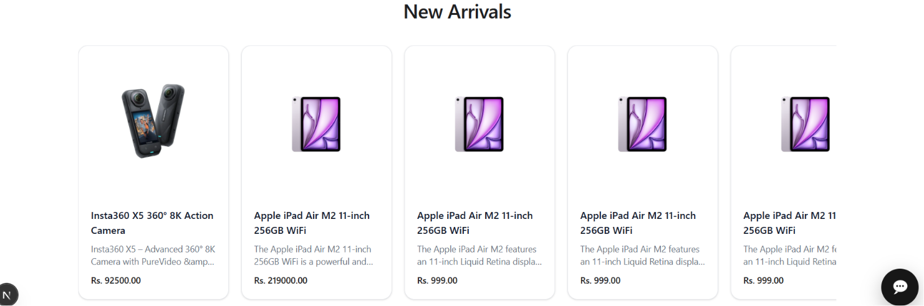
Fig: New Arrivals Section of mac store client view
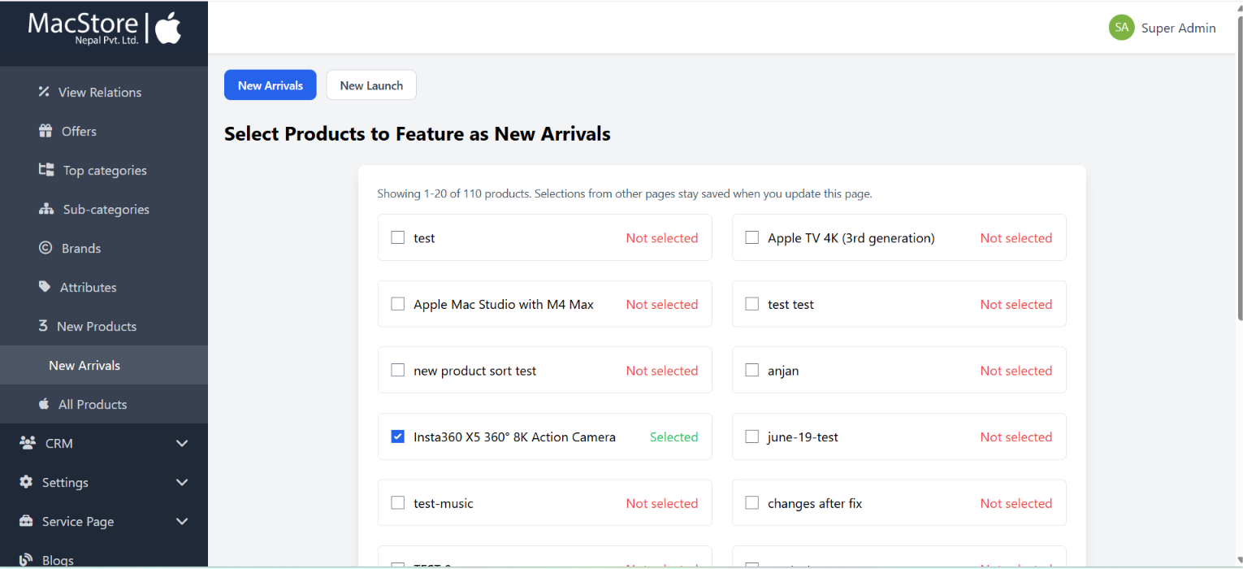
Fig: Admin Panel for selecting products to display in New Arrival

Frontend Directory Architecture:
The New Arrival section follows a simple component-based structure where the homepage acts as the entry point and the New Arrival component manages the complete functionality, including data fetching, state handling, and product display.
The New Arrival module uses a lightweight structure where the homepage is responsible only for component integration, while the NewArrivals.tsx component contains the complete feature logic, including API communication, data processing, and UI rendering.
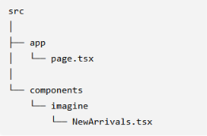
Fig: Directory Architecture of New Arrivals Implementation

API Documentation:
Base URL
https://demo.macstore.com.np/api
1. Get New Arrival Products
Returns a list of recently added products that are displayed in the New Arrivals section on the homepage.
The API provides product information including product name, image, description, price, and product identifier. The frontend uses this data to create product cards and navigate users to the respective product detail pages.
Endpoint
GET /new-arrivals-products
Example Request
GET https://demo.macstore.com.np/api/new-arrivals-products
Response (200 OK)
{
"success": true,
"message": "New arrivals fetched successfully.",
"source": "curated",
"data": [
{
"id": 129,
"name": "Insta360 X5 360° 8K Action Camera",
"slug": "Insta360-X5-8K-Action-Camera-price-in-nepal",
"description": "<p>Product description...</p>",
"price": "92500.00",
"stock_status": "in_stock",
"status": "active",
"main_image": [
"images/main/product-image.webp"
],
"created_at": "2026-06-20T11:26:35.000000Z"
}
]
}
Response Fields:
Root Fields:
Field | Type | Description
success | boolean | Indicates whether the API request was successful
message | string | Response message from the server
source | string | Indicates the source type of new arrival products
data | array | List of new arrival products

Product Object Fields:
Field | Type | Description
id | integer | Unique identifier of the product
name | string | Product name displayed on the product card
slug | string | Unique product slug used for navigation
description | string | Product description in HTML format
price | string | Current product selling price
stock_status | string | Current stock availability status
status | string | Product status
main_image | array/string | Product image paths used for displaying product images
created_at | datetime | Product creation date
updated_at | datetime | Product last updated date

Frontend Usage
The API response is used by the New Arrival section to display product cards.
The frontend uses:
- name → Display product title
- main_image → Display product image
- description → Display short product description
- price → Display product price
- slug → Generate product detail page URL
Notes
- Products displayed in this section are managed from the admin panel.
- The frontend only consumes the curated product list provided by the API.
- No product creation or management happens from the frontend.
- The API returns complete product objects, but the New Arrival section uses only the required display fields.

New Launches Section Integration

Introduction:
The New Launches section follows a hybrid component architecture where product data is fetched on the server side and passed to a client component responsible for interactive features such as carousel scrolling, user interaction, and product display.
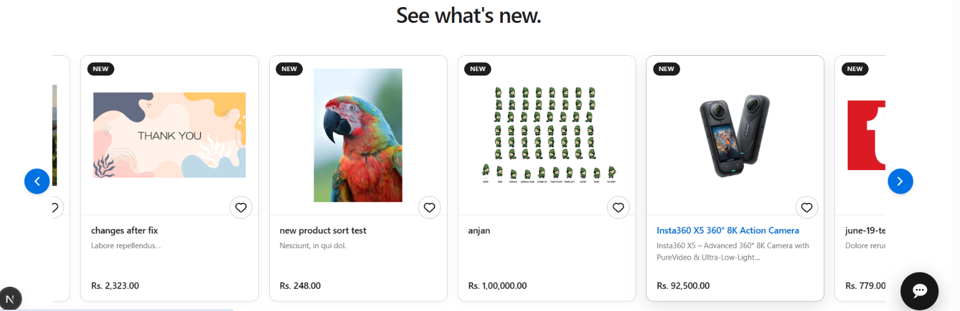
Fig: New Launches Section of mac store client view
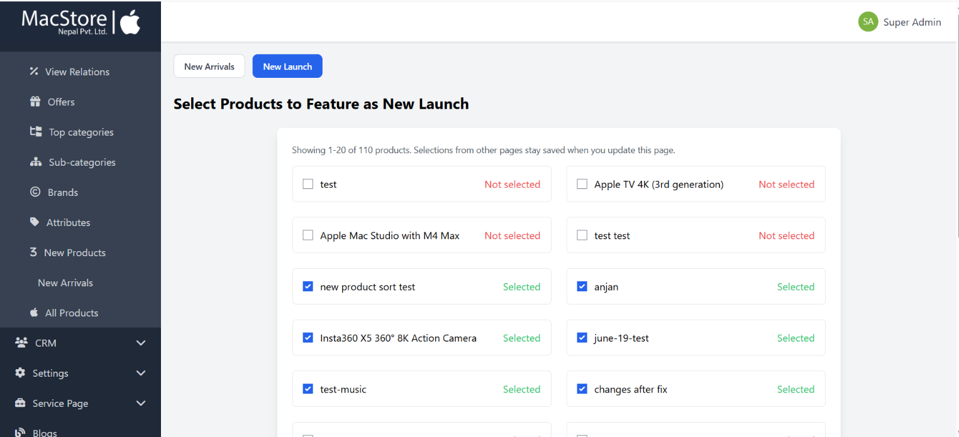
Fig: Admin Panel for selecting products to display in New Launches

Frontend Directory Architecture:
The New Launches section follows a component-based architecture where the homepage acts as the entry point and the New Launches module separates data fetching and interactive product display responsibilities between server and client components.
The New Launches module uses a structured approach where the page.tsx file is responsible only for integrating the section into the homepage, while NewLaunches.tsx handles product data fetching, API response processing, and data preparation. The NewLaunchesClient.tsx component manages the client-side functionality, including product display, carousel interactions, scrolling behavior, and user interactions.
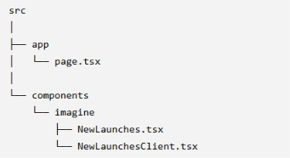
Fig: Directory Architecture of New Launches Implementation

API Documentation:
Base URL:
https://demo.macstore.com.np/api
1. Get New Launch Products
Returns a list of newly launched products that are displayed in the New Launches section on the homepage.
The API provides curated product data including product information, images, pricing, and product identifiers. The frontend uses this data to display the product carousel and allow users to navigate to product detail pages.
Endpoint
GET /new-launch-products
Example Request
GET https://demo.macstore.com.np/api/new-launch-products
Response (200 OK)
{
"success": true,
"message": "New launch fetched successfully.",
"source": "curated",
"data": [
{
"id": 131,
"name": "new product sort test",
"slug": "new-product-sort-test",
"description": "<p>Product description...</p>",
"price": "248.00",
"stock_status": "in_stock",
"status": "active",
"main_image": [
"images/main/product-image.jpg"
],
"created_at": "2026-06-22T06:18:22.000000Z",
"updated_at": "2026-06-22T06:19:12.000000Z"
}
]
}
Response Fields
Root Response
Field | Type | Description
success | boolean | Indicates whether the API request was successful
message | string | Response message returned by the API
source | string | Indicates the source of the product collection
data | array | List of newly launched products

Product Object
Field | Type | Description
id | integer | Unique identifier of the product
name | string | Product name displayed in the product card
slug | string | Unique product slug used for product page navigation
description | string | Product description in HTML format
price | string | Current product price
base_price | string | Original/base product price
main_image | string/array | Product image path used for displaying product image
stock_status | string | Current stock availability status
status | string | Product active status
sku | string | Product SKU identifier
created_at | datetime | Product creation date
updated_at | datetime | Product last update date

Notes:
- New Launch products are managed from the admin panel.
- The frontend only retrieves and displays products provided by the API.
- Product creation, editing, and management are handled outside the frontend.
- The API returns complete product information, but the New Launches section only uses the required display fields.

Country-State-City-Suggestion Integration:

Introduction:
The Country-State-City Suggestion module provides location-based suggestions during the checkout process to improve the customer address entry experience. It allows users to select their country, state/province, and city through structured suggestion fields instead of manually entering location details.
The integration uses a combination of the country-state-city library and custom location data handling. The library provides general country, state, and city information, while custom constants are maintained for locations where the library data is incomplete or outdated, such as Nepal's state/province information.
The module is integrated into the checkout flow, where location selections are used while collecting customer shipping details. The implementation handles location data fetching, formatting, and suggestion logic separately to keep the checkout components clean and reusable. It also uses server-side route handlers for location data access, reducing direct dependency on external APIs during user interaction.
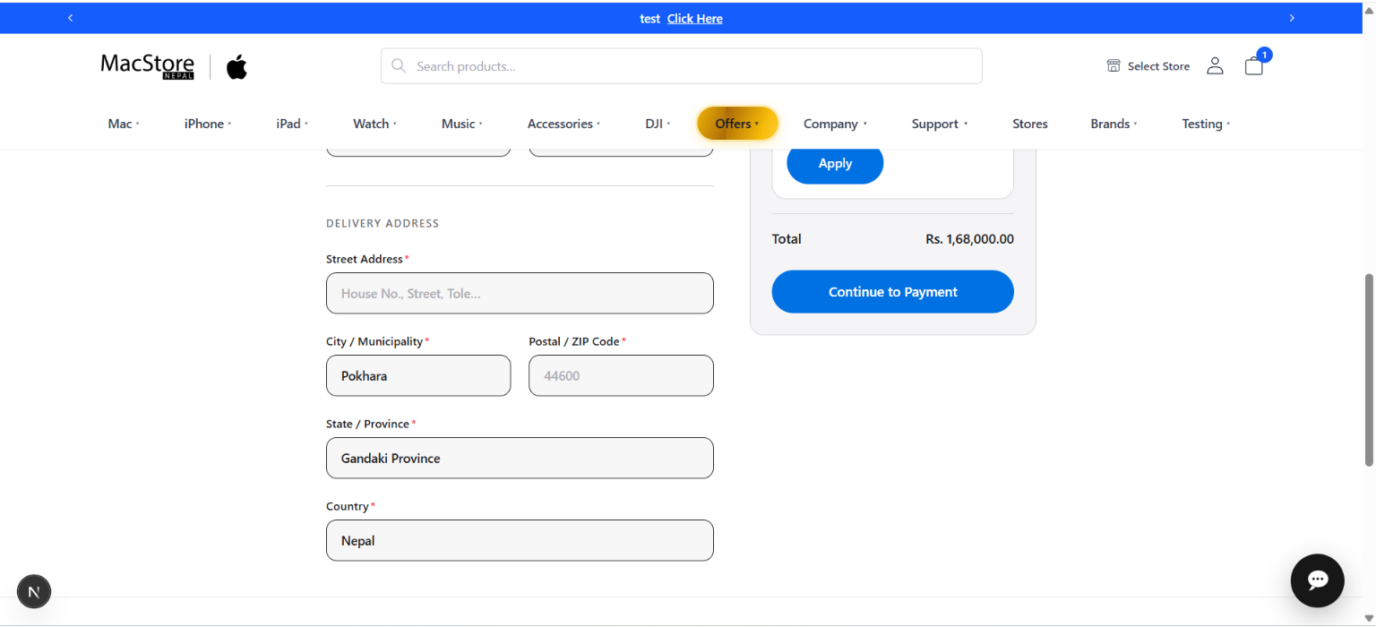
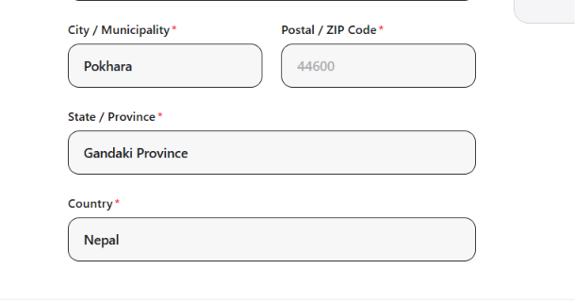
Fig: Integrated suggestion in Checkout page

System Architecture:
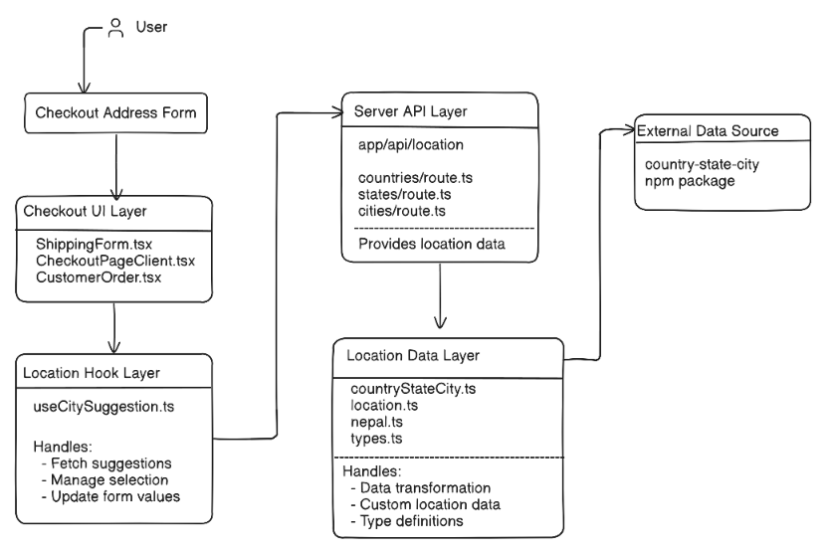
Fig: System Architecture of Country State City Suggestion
- Checkout UI Layer
  - The checkout components provide the interface where customers enter shipping information.
  - Location fields use suggestion-based selection for country, state, and city values.
- Location Hook Layer
  - useCitySuggestion.ts manages the client-side location suggestion workflow.
  - It communicates with the location API routes and provides formatted location data to checkout components.
- Server API Layer
  - Next.js API route handlers expose location data internally:
    - /api/location/countries
    - /api/location/states
    - /api/location/cities
  - These routes act as a bridge between the frontend and location data sources.
- Location Data Layer
  - The adapter layer normalizes data from different sources.
  - countryStateCity.ts handles library-based location data conversion.
  - nepal.ts provides manually maintained location constants for missing or outdated Nepal location data.
  - Shared types ensure consistent data structure across the module.
- External Data Source
  - The country-state-city package provides country, state, and city information.
  - Custom data overrides are used where package data does not meet application requirements.
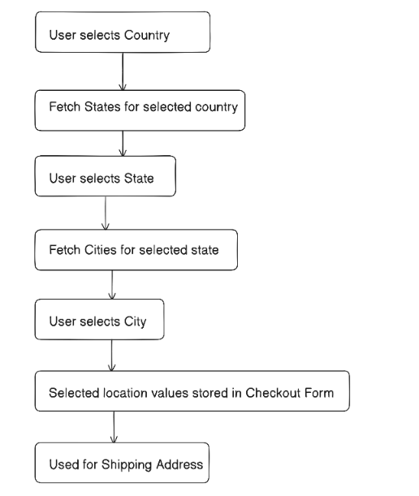
Fig: System Flow of Country State City Suggestion Integration

Frontend Directory Architecture
The Country-State-City Suggestion module provides location selection functionality during checkout by allowing users to select countries, states, and cities through searchable suggestions.
The module uses the country-state-city library "country-state-city": "^3.2.1", for location data management and extends it with custom location constants where additional accuracy is required. The location data is processed on the server side and exposed through internal API routes, which are consumed by frontend components.
The architecture separates location data handling, server routes, reusable hooks, and checkout UI components to keep the implementation organized and maintainable.
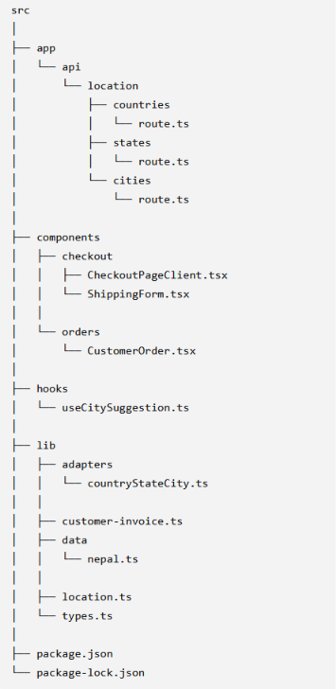
Fig: Directory Architecture of Country-State-City-Suggestion
The Country-State-City Suggestion module combines a third-party location library with custom location data to provide accurate address selection during checkout. The server-side API route approach keeps location processing centralized, avoids dependency exposure to the client, and avoids external API limitations because the data is handled locally within the application.

Category Navigation Integration

Introduction:
The Category Navigation module allows users to browse products through a hierarchical category structure. The navigation is dynamically populated from backend APIs, ensuring that any categories created or updated from the admin panel are automatically reflected on the frontend without requiring code changes.
The navigation consists of two levels:
- Top Categories – Primary product categories displayed in the main navigation.
- Subcategories – Child categories displayed under their respective top category.
When a user selects a category or subcategory, the application retrieves and displays the corresponding products by making API requests to the backend.
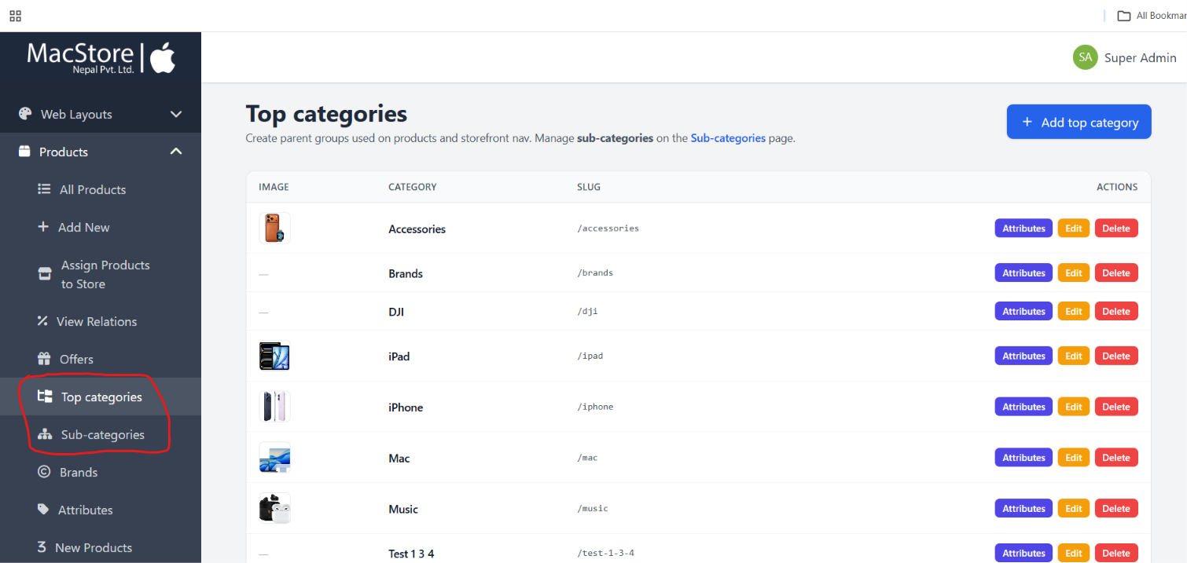
Fig: Admin panel to Create Top and Subcategory
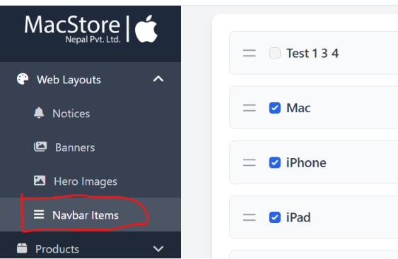
Fig: Admin panel to list top category in Client View Navigation
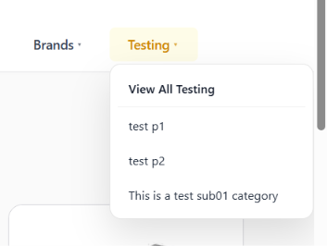
Fig: Client Side Navigation View Top and Sub Category

System Workflow:
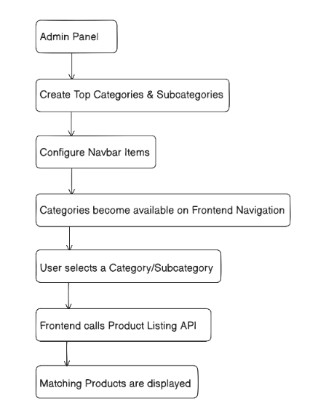
Fig: Category Navigation Workflow
The category navigation displayed on the frontend is managed through the admin panel. Administrators create top categories and subcategories and configure which categories appear in the website navigation. When users select a category or subcategory, the frontend requests the corresponding products from the backend and displays them on the product listing page.

API Documentation:
Base URL
https://demo.macstore.com.np/api
1. Get Products by Top Category
Returns all products belonging to a selected top-level category. This API is used when a user selects a category from the main navigation menu.
Endpoint
GET /products/category/{category}
Path Parameters
Parameter | Type | Description
category | string | Slug or name of the top category
Example Request
GET https://demo.macstore.com.np/api/products/category/testing
Success Response (200 OK)
[
{
"id": 107,
"sku": "MPWU3ZM/A-DUP-107",
"slug": "ipad-air-2024-m2-256gb",
"store_id": null,
"name": "Apple iPad Air M2 11-inch 256GB WiFi",
"description": "<p>The Apple iPad Air M2 11-inch 256GB WiFi is a powerful and ultra-light tablet designed for work, creativity, entertainment, and everyday use. Powered by Apple’s advanced M2 chip, it delivers fast performance for multitasking, gaming, video editing, note-taking, and AI-powered apps. The 11-inch Liquid Retina display offers sharp visuals, vibrant colors, and smooth touch responsiveness, making it ideal for streaming, studying, and creative work.</p>",
"price": "219000.00",
"stock_status": "in_stock",
"main_image": "[\"images\\/main\\/1779023157_6a09bd3548982.jpg\"]",
"meta_tags": "Apple, iPad Air, M2, tablet, iPad 11 inch, Apple tablet, iPad WiFi, iPad 2024",
"meta_description": "Buy the Apple iPad Air M2 11-inch 256GB WiFi with powerful M2 performance, stunning Liquid Retina display, all-day battery life, official warranty, fast shipping, installment options, and exciting trade-in offers.",
"features": "<p>Apple M2 chip for fast and smooth performance</p><p>11-inch Liquid Retina display with True Tone technology</p><p>256GB storage for apps, files, photos, and videos</p><p>Wi-Fi 6E connectivity for faster internet speeds</p><p>Supports Apple Pencil Pro and Apple Pencil (USB-C)</p><p>USB-C port for charging and accessories</p><p>Touch ID built into the top button for secure unlocking</p><p>Lightweight and portable aluminum design</p><p>Up to 10 hours of battery life for all-day usage</p><p>Ideal for students, creators, professionals, and entertainment lovers</p>",
"warranty": "<p>1 Year Official Apple Limited Warranty</p><p>Covers manufacturing defects and hardware issues</p><p>Warranty service available through authorized Apple service centers</p>",
"inthebox": "<p>Apple iPad Air M2 11-inch 256GB WiFi</p><p>USB-C Charge Cable</p><p>20W USB-C Power Adapter</p><p>User Guide &amp; Documentation</p>",
"installment_options": "Apple iPad Air M2 11-inch 256GB WiFi\r\nUSB-C Charge Cable\r\n20W USB-C Power Adapter\r\nUser Guide & Documentation",
"shipping_details": "Free standard shipping on eligible orders\r\nDelivery within 2–5 business days depending on location\r\nSecure packaging with tracking support\r\nExpress delivery available in selected areas",
"uptrade": "Exchange your old iPad or tablet for discount benefitsAdditional seasonal sales and student offers may applyCashback and promotional discounts available during special campaigns",
"imei": "24 Months EMI Available",
"keywords": "ipad air m2, apple ipad 11 inch, ipad 256gb wifi, apple tablet, ipad m2 price, ipad air 2024",
"category": {
"id": 20,
"name": "Testing",
"slug": "testing",
"image": "https://demo.macstore.com.np/storage/top_categories/1781686873_Test-Logo.svg.png"
},
"subcategory": {
"id": 99,
"name": "test p1",
"slug": "test-p1"
},
"attributes": [],
"accessories": []
},
{},
{},
…. ]

Notes
- Returns all products associated with the selected top category.
- Each product includes category and subcategory information.
- Product details are displayed in the category listing page.
2. Get Products by Subcategory
Returns products belonging to a specific subcategory under a selected top category. This API is used when a user selects a subcategory from the navigation menu.
Endpoint
GET /products/category/{category}?subcategory={subcategory}
Path Parameters
Parameter | Type | Description
category | string | Name or slug of the top category
Query Parameters
Parameter | Type | Description
subcategory | string | Slug or name of the subcategory
Example Request
GET https://demo.macstore.com.np/api/products/category/Music?subcategory=testing
Success Response (200 OK)
[
{
"id": 128,
"sku": "Irure ad debitis con",
"slug": "june-19-test",
"store_id": null,
"name": "june-19-test",
"description": "<p>Dolore rerum perspic.</p>",
"price": "779.00",
"stock_status": "in_stock",
"main_image": "[\"images\\/main\\/1781851733_6a34e65572ba4.png\"]",
"meta_tags": "Impedit deleniti ve",
"meta_description": "Neque est enim dolor",
"features": "<p>Quia est quibusdam e.</p>",
"warranty": "<p>Blanditiis ducimus, .</p>",
"inthebox": "<p>Autem excepturi culp.</p>",
"installment_options": "Maiores duis in fuga",
"shipping_details": "Ut amet consequatur",
"uptrade": "Fugiat eos commodo",
"imei": "Quia id placeat sit",
"keywords": "Blanditiis eum aliqu",
"category": {
"id": 5,
"name": "Music",
"slug": "music",
"image": "https://demo.macstore.com.np/storage/top_categories/1782037384_Music.jpg"
},
"subcategory": {
"id": 102,
"name": "testing",
"slug": "testing"
},
"attributes": [],
"accessories": []
}
]

Notes
- Filters products within the selected top category using the provided subcategory.
- Used when users navigate through subcategory links.
- Returns only products matching both the selected category and subcategory.

FAQ Page Documentation

Introduction:
The FAQ page provides answers to commonly asked customer questions regarding services, warranty, payment methods, and support. The page is implemented as a static frontend page and does not consume any backend APIs.

Implementation:
- Built as a static Next.js page.
- FAQ items are maintained directly within the component as a local data array.
- Questions and answers are rendered dynamically by iterating over the local array.
- Uses the native HTML <details> and <summary> elements to provide expandable and collapsible FAQ items.
- No database or admin panel integration is required.

Frontend Directory Architecture:
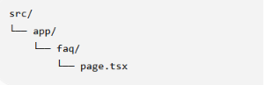
Fig: Directory Architecture of FAQs
Data Source
Source | Type
Local array (faqs) | Static
Notes
- The FAQ content is hardcoded in the frontend.
- Any updates to questions or answers require modifying the source code and redeploying the application.
- No API requests are performed when rendering this page.

Service Section (Homepage)

Introduction
The homepage Service section is fully managed through the admin panel. Administrators can create, update, or remove services without modifying the frontend code. Each service includes information such as the service name, slug, description, and image. Once a service is published, it becomes available through the Services API and is automatically displayed on the homepage.

System WorkFlow:
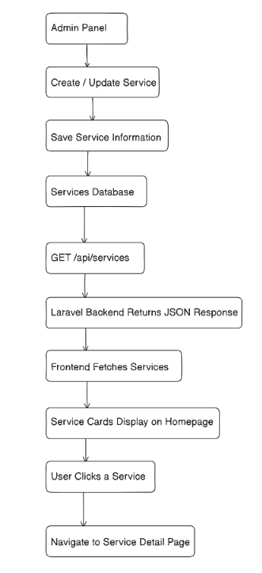
Figure: Workflow of Service Management and Homepage Display

API Documentation
Base URL
https://demo.macstore.com.np/api/services
Method: GET
Description:
Returns all available services configured in the backend. The frontend retrieves this list, filters active services, and displays them as cards in the homepage carousel.
Request
No request body or parameters are required.
Response
{
"success": true,
"message": "Services retrieved successfully",
"data": [
{
"id": 1,
"name": "Device Repair Service",
"slug": "device-repair",
"description": "Phone, MacBook, iPad hardware & software repair\r\nScreen replacement\r\nBattery replacement\r\nWater damage",
"icon": null,
"price": null,
"estimated_time": null,
"created_at": "2026-05-05T12:50:05.000000Z",
"updated_at": "2026-05-05T12:50:05.000000Z",
"main_image": "services/lIceih2q2jPW9XTzI2RiKui9GryPXELjI3AsbXx1.png"
},
{},
{},
]
}

Response Fields
Field | Description
success | Indicates whether the request was successful.
message | Response status message.
data | Array containing all available services.
id | Unique identifier of the service.
name | Service title displayed on the homepage.
slug | Used for navigation to the service detail page.
description | Short description shown on the service card.
main_image | Image associated with the service.

